Equalities Monitoring

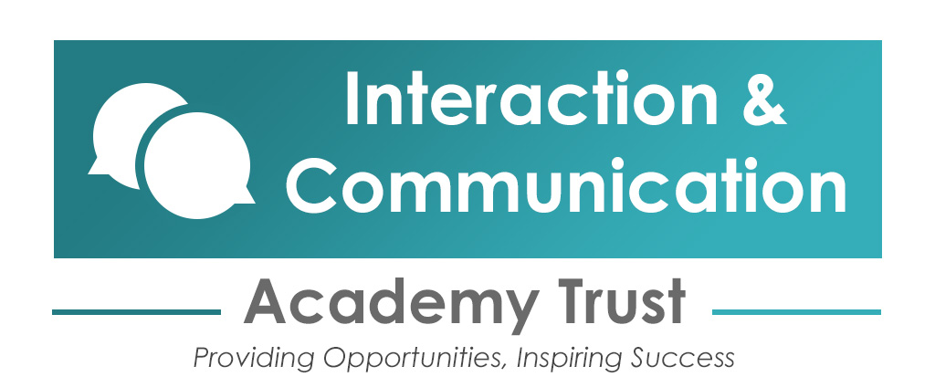

Equalities monitoring
We’re bound by the Public Sector Equality Duty to promote equality for everyone. To assess whether we’re meeting this duty, whether our policies are effective and whether we’re complying with relevant legislation, we need to know the information requested below.
This information will not be used during the selection process. It will be used for monitoring purposes only.
Equalities monitoring information
What is your date of birth? | D | D | M | M | Y | Y | Y | Y
What gender are you? | ☐Male  ☐Female  ☐Non Binary  ☐Prefer not to say
Do you identify as the gender you were assigned at birth? | ☐Yes  ☐No  ☐Prefer not to say

How would you describe your ethnic origin?
White  ☐British  ☐Irish  ☐Gypsy or Irish Traveller  ☐Any other White background  Asian or British Asian  ☐Bangladeshi  ☐Indian  ☐Pakistani  ☐Chinese | Black or Black British  ☐African  ☐Caribbean  ☐Any other Black background  Mixed  ☐White and Asian  ☐White and Black African  ☐White and Black Caribbean  ☐Any other mixed background | Other Ethnic groups  ☐Arab  ☐Any other ethnic group  ☐Prefer not to say
Which of the following best describes your sexual orientation?
☐Bisexual
☐Heterosexual/straight
☐Homosexual man
☐Homosexual woman
☐Other
☐Prefer not to say
What is your religion or belief?
☐Agnostic  ☐Atheist  ☐Buddhist  ☐Christian  ☐Hindu | ☐Jain  ☐Jewish  ☐Muslim  ☐No religion | ☐Other  ☐Pagan  ☐Sikh  ☐Prefer not to say
Are your day-to-day activities significantly limited because of a health problem or disability which has lasted, or is expected to last, at least 12 months?
☐Yes
☐No
☐Prefer not to say
If you answered ‘yes’ to the question above, please state the type of impairment. Please tick all that apply. If none of the below categories applies, please mark ‘other’.
☐Physical impairment
☐Sensory impairment
☐Learning disability/difficulty
☐Long-standing illness
☐Mental health condition
☐Developmental condition
☐Other

