Educational Teaching Assistant – Grade 6

Information for Candidate

Birmingham Lane

Meltham

Holmfirth

HD9 5LH

Tel: 01484 859032

With Compliments

Liz Woodfield
Headteacher

MELTHAM MOOR PRIMARY SCHOOL

Birmingham Lane, Meltham, Holmfirth. HD9 5LH

Head Teacher – Liz Woodfield
Tel: 01484 859032
e-mail: office@melthammoor.org
website: www.melthammoor.org

October 2020

Dear Applicant,
Thank you for your interest in the post on offer at our school. We hope this information pack containing details of the position and the school is helpful.
To assist you in making a successful application, the points below are given for your guidance:
- Please complete all elements of the application form fully
- A supporting letter should address all criteria in the Personnel Specification.
- This letter should be no more than two sides of A4 using Arial font no less than size 11
- Completed forms should be handed in at the school or emailed to office@melthammoor.org by 12.00pm on Monday 2nd November 2020.
- A CV is not required.
- Please mention to your referees that references for shortlisted candidates will be requested at short notice.

Yours sincerely,

Liz Woodfield
Headteacher

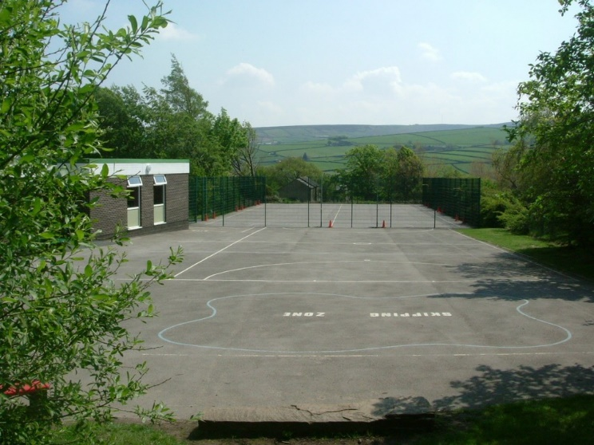

Meltham Moor is a through primary school set in beautiful surroundings on the edge of the Peak District National Park. We have approximately 220 children in classes ranging from Nursery to Y6.
Our school vision statement is clear:
‘At Meltham Moor we will endeavour to ensure that every child can achieve their best personally, socially and academically’.
Our values are:
Aspiration - encouraging everyone to be the best that they can be.
Confidence - being prepared to take risks, without fear of failure, and developing self-esteem from recognising achievements.
Resilience - being able to bounce back and try again.
Compassion - being friendly, caring, well-mannered and behaving appropriately, supporting and respecting each other.
A love of learning.

Governors and staff believe that children work better and learn more effectively in an atmosphere of friendliness but within a framework of good order which engenders good behaviour. Emphasis is placed upon the establishment of good relationships between staff and children and between home and school.

In September 2019, Meltham Moor entered the newly formed Together Learning Trust. Being part of the Together Learning Trust will enable our schools to continue to flourish and develop within a supportive school focused community, where the expertise of those who have a hands on understanding of our children will lead the way forward.

At Meltham Moor we aim for children to develop awareness of responsibilities towards themselves, others and their environment. The children are actively encouraged to make positive contributions to their own education, school and community in general. We are a happy, positive school and we look forward to a productive time and successful future. We believe strongly in the partnership between home and school and want families to be actively involved in supporting children's learning and the school.

Applications are invited for the post of:

Educational Teaching Assistant

We are seeking to appoint an effective and creative educational teaching assistant with high expectations, who is able to motivate children to make good progress. If you are a committed, energetic, inspirational member of staff, we would like you to join our successful team.
We can offer:
- Happy, enthusiastic children who are eager to learn;
- Friendly and supportive staff, governors and parents
- A highly committed team that embraces change;
- Exciting opportunities to work with colleagues across the Together Learning Trust;
- A strong local partnership of schools;
- outstanding resources and facilities;
- An outstanding working environment;
- Excellent professional development opportunities.
In return, we are looking for members of staff who are:
- Outstanding classroom practitioners with high expectations.
- Committed to raising standards by being passionate about enabling every child to fulfil their potential.
- Willing to be fully involved in the life of the school.
- Excellent at building good working relationships with children, parents, staff and governors.
- Trained and experienced in the phase they are applying for.

We are committed to safeguarding and promoting the welfare of children and young people and expect all staff and volunteers to share this commitment. All staff are subject to an enhanced DBS check.

To apply for this role, please download and complete an application form attached. A CV is not required.
Completed applications should be returned to the school by email office@melthammoor.org, by 12.00pm on Monday 2nd November 2020

Job Description
Educational Teaching Assistant Grade 6

PURPOSE OF JOB

- Supporting pupils by implementing individual behaviour plans set by teachers and/or Senior Leader
- Working with outside agencies, implementing recommended strategies
- Working under the guidance of teaching/senior staff to implement and oversee agreed work programmes with individuals/groups, in or out of classroom. This could include those requiring detailed and specialist knowledge in particular areas and will involve assisting the teacher in the whole planning cycle and the management/preparation of resources.

KEY AREAS

- Teaching Support
- Pupil Support
- Curriculum Activities
- General

DUTIES AND RESPONSIBILITIES

1. Teaching Support

  - To undertake duties in accordance with school practices and procedures, ensuring the job holder actively upholds and promotes the philosophies of the school.

  - Supporting pupils who need help overcoming barriers to learning because of social, emotional and behaviour difficulties

1.2 To work under the guidance of the class teacher/line manager to plan and monitor pupils learning. Ensuring the progress is clearly recorded in the relevant systems and relates to the learning objectives/goals for pupils.

1.3 As appropriate to assist with the induction and mentoring of new staff within the remit of the role.

1.4 Under the guidance of the teacher provide one to one support to pupils or working with groups of pupils on pre-planned activities, to reinforce the teachers approach.

1.5 To assist where required in the planning of learning activities.

  - Under the guidance of the teacher ensure equipment or materials are suitable for the learning activities. Prepare materials and teaching aids where necessary.

  - Under the guidance of the teacher work with individuals or groups of pupils in accessing school library and in the use of ICT and other relevant resources to support learning.

  - To participate in and assist in supervision of educational visits, in conjunction with the teacher/line manager.

1.9 Promote good behaviour, dealing promptly with conflict and incidents in line with established policy and encourage pupils to take responsibility for their own behaviour.

2. Pupil Support

  - Provide support and guidance on a one to one basis or to teams of
pupils in their core skills and curriculum needs as per school policies/practices.

  - Working with others in providing day-to-day guidance and support for pupils who disrupt
the learning of others

  - To actively encourage the inclusion of all pupils to participate in the life and activities of
the school and access the national curriculum to the best of their ability.

  - To provide individual assistance or assistance within groups through implementing
behaviour plans, Individual Education Plans and teaching strategies etc, to maximise
their achievements.

  - As required to deal with pupils who require physical restraint and intervention, using such methods as TEAM-TEACH, under the direction of the Headteacher.

2.5 As required, to deal with the personal care and comfort and necessary minor medical treatments of pupils, i.e. toileting and intimate care issues (as per school guidance and direction).

2.6 To contribute to plans, reviews and evaluations of pupils by writing reports on pupils’ progress and attendance at meetings.

3. Curriculum Activities

  - To maintain stock of resources, ordering new replacements as agreed with colleagues, to support the work across the team in its delivery of service.

  - To contribute in the presentation of pupils’ work and maintenance of display areas.

  - To assist with the preparation and tidying of the classroom and upkeep of resources.

  - To attend and contribute to duty related meetings as required.

3.5 To assist in the planning and implementation of structured and agreed learning activities/teaching programmes.

4. General

4.1 As part of your wider duties and responsibilities you are required to promote and actively support the school’s responsibilities towards safeguarding. Safeguarding is about keeping people safe and protecting people from harm, neglect, abuse and injury. It is about creating safe places, being vigilant and doing something about any concerns you might have. It isn’t just about the very old and the very young, it is about everyone who may be vulnerable.

Carry out your duties with due regard to current and future school’s policies, procedures and relevant legislation. These will be drawn to your attention in your appointment letter, your statement of particulars, induction, ongoing performance development and through School communications.
_________________________________________________________________

RESPONSIBLE TO: Head Teacher/Class Teacher
________________________________________________________

JOB TITLE: Educational Teaching Assistant GRADE: 6

 | ATTRIBUTES |  | RELEVANT CRITERIA | HOW IDENTIFIED | RANK
1. | RELEVANT EXPERIENCE | 1.1  1.2  1.3  1.4  1.5 | Experience of working with children/young people in a school environment.  Experience of assisting class teacher in delivering the curriculum.  Experience of working with children with challenging behaviour  Experience of working with children with additional needs  Recent experience of EYFS and the primary curriculum | Application Form/ Selection Process  Application Form/ Selection Process  Application Form/ Selection Process  Application Form/ Selection Process | A  B  A  A  A
2. | EDUCATION AND TRAINING ATTAINMENTS | 2.1  2.2  2.3 | English and Mathematics at GCSE Grade C/Grade 4 (or above)  NVQ 3/4 for Teaching Assistants or equivalent qualifications  Relevant professional development | Application Form/ Selection Process  Application Form/Certificates  Application Form/ Certificates | A  B  B
3. | GENERAL AND SPECIAL KNOWLEDGE | 3.1  3.2  3.3  3.4  3.5 | Understanding of National Foundation Stage curriculum and other current learning programmes/strategies.  Good understanding of Child Development and Learning.  Knowledge and understanding of behaviour management strategies  Knowledge of equality and diversity issues  Good understanding of safeguarding in schools | Selection Process  Selection Process  Selection Process  Application Form/ Selection Process  Application Form/ Selection Process | A  A  B  B  A

 | ATTRIBUTES |  | RELEVANT CRITERIA | HOW IDENTIFIED | RANK
4. | SKILLS AND ABILITIES | 4.1  4.2  4.3  4.4  4.5  4.6 | Effective use of ICT to support learning.  Ability to assist the teacher in planning class activities.  Ability to communicate effectively with pupils and staff members.  Ability to relate to children/young people from diverse/social backgrounds.  Ability to work as a team member.  Ability to work with children exhibiting behavioural difficulties. | Application Form/ Selection Process  Selection Process  Application Form/ Selection Process  Selection Process  Application Form/ Selection Process  Application Form/ Selection Process | A  A  A  A  A  A
5. | ANY ADDITIONAL FACTORS | 5.1  5.2  5.3 | Understanding of relevant policies/codes of practice and awareness of relevant legislation.  Commitment to ongoing personal training and development.  Willingness to undertake an enhanced Disclosure and Barring Service check. Please note a conviction may not exclude candidates from employment but will be considered as part of the selection process. | Selection Process  Selection Process  Application Form/ Selection Process | B  A  A

Please make sure that you demonstrate your ability to meet the requirements of the job by giving clear, concise examples of how you meet each criteria on your application form. The letters A, B and C in the "Rank" column refer to the importance we will give your answers when we read your applications. You must have all the A's on day one to be able to do the job, you need to have all the B's to do the job, but they could be learnt during the induction, and if you have C criteria this would be an additional bonus. We recognise and welcome our responsibility to remove any barriers in our Recruitment and Selection process for disabled people. We have tried to do this, but if you have a disability and identify any barriers in the job description or employee specification, please tell us of these in your application. We are committed to making reasonable adjustments to the job wherever possible and it would help us to know your needs in order to do this.

_________

