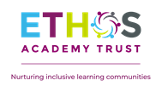
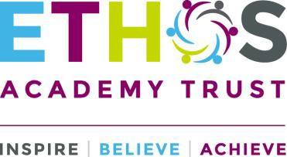

Application for Employment Equal Opportunities Monitoring
Job Title: …………………………

Please return this form by e-mail to recruitment@eat.uk.com
or by post to Ethos Academy Trust, c/o Ethos College, Knowles Hill Road, Dewsbury, WF13 4QS

The information that you provide as an applicant is confidential and will only be used to produce statistics for equality and recruitment monitoring only, and will not be shared with the Recruitment Panel.

Completing this form and providing as much information as possible will help us to:-

- Monitor our progress around equality and diversity representation within our workforce.

- Remove barriers in our recruitment, retention and development processes for potential and existing employees and aim to ensure that people from all sections of our community have fair and transparent opportunities within all areas of the Trust’s control.

- Look at groups that are under-represented and consider positive action strategies to encourage people from all groups to apply.

Ethos Academy Trust recognises that all employees have an individual responsibility in the promotion of equality and diversity.

Information about you

Name / Gender / Date of Birth Name:

Gender / DOB: Male ☐ Female ☐ Date of birth

Continued overleaf

Registered address: Ethos Academy Trust, c/o Reach Academy, Batley Field Hill, Batley, WF17 0BQ. A charitable company limited by guarantee registered in England and Wales (company number: 10745840).

Ethnicity

How would you describe your ethnic origin? (tick  one box only) White English / Welsh / Scottish / Northern Irish / British ☐
Irish ☐

Any other White background ☐ (please write in)

Asian or Asian British Indian ☐ Pakistani ☐ Bangladeshi ☐ Kashmiri ☐

Any other Asian background ☐ (please write in)
Black or Black British ☐ Caribbean ☐ African ☐
Any other Black background ☐ (please write in)
Mixed White and Black Caribbean ☐ White and Black African ☐

White and Asian ☐
Any other mixed background ☐ (please write in) Chinese ☐
Any other Ethnic Origin ☐ (please write in)

Disability

Do you consider yourself to be a disabled person?

Yes ☐ No ☐

Continued overleaf

Registered address: Ethos Academy Trust, c/o Reach Academy, Batley Field Hill, Batley, WF17 0BQ. A charitable company limited by guarantee registered in England and Wales (company number: 10745840).

Sexual Orientation

How would you describe your sexual orientation? (tick  one box only)

Heterosexual/Straight ☐ Gay man ☐ Lesbian/Gay woman ☐ Bisexual ☐
I am not prepared to say ☐
None of these ☐ (please write in)

Religion

What is your religion, even if you are not currently practising? (tick  one box only)

Buddhist ☐ Christian ☐ Hindu ☐ Jewish ☐ Muslim ☐ Sikh ☐
No religion ☐
I am not prepared to say ☐ Any other ☐
(Please write in)

Thank you for taking the time to complete this form

Registered address: Ethos Academy Trust, c/o Reach Academy, Batley Field Hill, Batley, WF17 0BQ. A charitable company limited by guarantee registered in England and Wales (company number: 10745840).

