**CARETAKER**

**28.75 Hours per week**

**Scale 7**

**Information for Candidates**

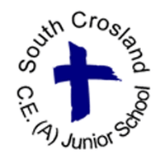

**South Crosland C.E. (A) Junior School**

**Moor Lane**

**Netherton**

**Huddersfield**

**HD4 7HF**

**Tel: 01484 667075**

**With Compliments**

**Clare Brewster**

**Head Teacher**

***Together, as one, we support each other to flourish and succeed***

**South Crosland C.E. (A) Junior School**



**Moor Lane**

**Netherton**

**Huddersfield**

**HD4 7HF**

**Tel: 01484 667075**

**e-mail: office@southcrosland.org.uk**

**website:** [**http://www.southcrosland.org**](http://www.southcrosland.org)

**Twitter: @CroslandJunior**

**Headteacher: Miss Clare Brewster**

Dear Applicant,

Thank you for your interest in the post on offer at our school. We hope this information pack containing details of the position and the school is helpful.

To assist you in making a successful application, the points below are given for your guidance:

* + Completed application forms should be returned to the Headteacher by emailing: [office@southcrosland.org.uk](mailto:office@southcrosland.org.uk) by 12 noon on Friday, 2.10.20.
  + Interviews will be held on Tuesday 13.10.20*.*

* + Please inform your referees that references for shortlisted candidates will be requested at short notice

Yours faithfully,

Miss Clare Brewster Mrs Janice Dorrington Headteacher Chair of Governors

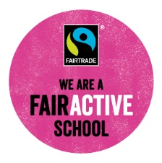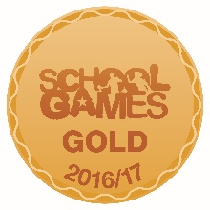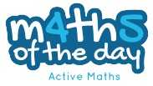

**South Crosland C.E.(A) Junior School**

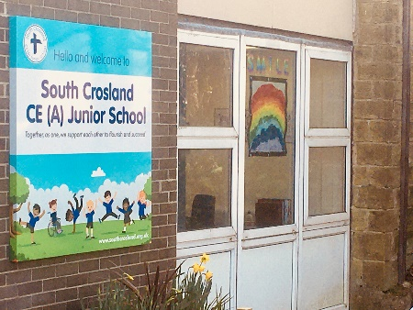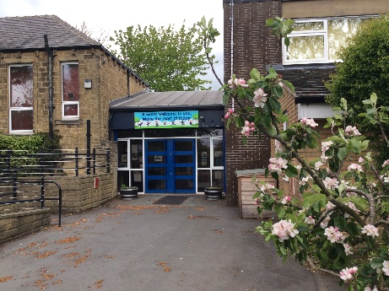

South Crosland is a two-form entry Church of England Junior School, with 228 children currently on roll.

The school is situated in the village of Netherton, approximately 3 miles from the centre of Huddersfield. Though so close to the town, we are in a semi-rural area with wonderful countryside and views on our doorstep.

Most of our children transfer from Netherton Infant and Nursery School which is situated approximately 400m from the Junior School site.

The school has strong links with our church, Holy Trinity in South Crosland, and has a strong ethos, based on the Christian values of Friendship, Forgiveness, Honesty and Respect. The most recent SIAMS inspection in February 2018, judged the distinctiveness and effectiveness of our school as a Church of England school to be outstanding.

Our staff consists of: Head Teacher, Deputy Head Teacher, Assistant Headteacher, eight full-time teachers, three part-time teachers, a Business Manager, an Advanced Business Support Officer, four Cover Supervisors and seven Educational Teaching Assistants.

The school was last inspected by OFSTED in February, 2018. The report concluded that South Crosland C.E. (VA) Junior School continues to be a good school in which the curriculum inspires pupils and teachers to put high priority on developing pupils’ knowledge and skills across a broad range of subjects.

At South Crosland C.E.(A) Junior School, staff work as a team to help pupils make strong progress across school; Governors are committed to supporting this.

