Applicant Welcome Pack
Science technician

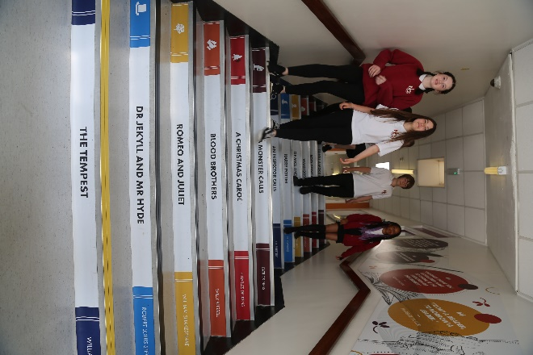
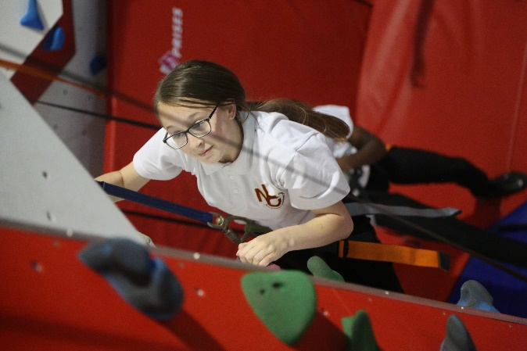

“Success For All”

Letter from the Principal

Dear Applicant,

Welcome and many thanks for your interest in the vacancy at our school. This information pack will provide you with an outline of the role for which you are considering applying and I would encourage you to undertake further research into our school and its community to make sure this is a role in which you can make a significant, positive impact on the lives of our students. Additionally, it needs to be the right place for you to develop professionally and to be happy in the next stage of your career.

Netherhall Learning Campus consists of four schools, covering the full age and ability range from 3 – 19 years, each with its own distinctive ethos; each with its own individual identity and each catering to the specific needs of its students. Whilst the four schools are linked by a common philosophy and by common expectations, each school has its distinct and own characteristics that offer all students a continuous journey from Early Years entry through Key Stages 1 to 4 and beyond to Key Stage 5 via the Studio School. We are made up of a diverse community, yet we are all Netherhall.

Our ethos of ‘Success for All’, caring for each other and achieving excellence, underpin everything that happens in our school. I believe education should have a positive impact on all students and that Netherhall is the right place for this to happen. We have the highest expectations of all our students in every area of school life. Our school is a caring, nurturing and ordered community with an atmosphere of calm and purposeful learning. Students are treated as individuals and we recognise and celebrate different abilities, aptitudes and interests and believe that everyone can develop through dedication and hard work. We aim to create an enjoyment for learning and a resilience that is essential for achieving excellence. We work hard to ensure every young person is happy, safe and successful – a credit to themselves, their family and Netherhall. We aim high.

A culture of excellent teaching and learning is at the heart of everything at Netherhall Learning Campus and it isn’t just for students; we invest heavily in the continuing professional development of all our staff to improve the student experience. Success is not down to one thing but needs some key ingredients: strong classroom practice, an appropriate and personalised curriculum, rigorous tracking and monitoring of progress, commitment and positive behaviour for learning from students and support from home. These coupled with a love for learning and a passionate belief that all can achieve are crucial so that every student can be the best that they can be.

We look forward to welcoming you into our school community.
Michael Kent
Principal
Our Vision
The vision of the Campus is one where everybody will aim to achieve the highest standards and where the Campus will maximise everyone’s potential.

“Success For All”
We will:

- provide relevant learning experiences that will enable students to acquire the essential knowledge, understanding and intellectual, physical and creative skills to equip them for later life.
- leave students at the end of their formal and full-time education with an appetite for acquiring further knowledge, skills and awareness throughout their lives.
- create high expectations of work and behaviour so that each student achieves their maximum potential.
- create a caring community whose basis is tolerance, understanding and concern for other people.
- create an inclusive and supportive environment which helps students become informed, confident, independent, involved and responsible citizens.
- encourage attitudes that enable children to be responsible members of both the school and local community and grow into well-adjusted adults and useful members of society
- recognise our responsibility to provide a safe environment in which all students feel included and valued, and in which there is celebration of all personal achievements and acceptance of diversity.
- broaden students’ horizons and increase their awareness of the world.

About the Campus
Among Kirklees schools, only Netherhall Learning Campus offers children and young adults with a continuous journey from Early Years entry through Key Stages 1 to 4 and beyond to Diploma, AS and A level studies, via the Studio School.

A continuous journey

Pupils may join any of the schools at any time. Regardless of the stage at which they start to attend, all students will experience the unique benefit of an education that has been planned by specialist teachers for all stages of a child’s learning journey.

A common standard and expectation of dress, behaviour and standards of presentation:
- All students, regardless of age, are expected to observe common rules of courtesy, respect, honesty and reliability.
- Uniform is the same across the campus.
- From the start of their school career, all pupils are expected to arrive on time and with the correct equipment.
- Work is always to be presented to the best of the pupils’ ability and books are to be respected and kept in good condition.

A recognition of the importance of parents and carers as partners in the learning journey of our children. A dedicated community team works across the campus to:
- Work with parents to help support their children.
- Encourage greater parent and carer participation in school.
- Support adults who may have had a career break, back into learning and into the workplaces.

High quality teaching
- Teachers across the campus meet regularly to share ideas and good practice.
- They share their expertise and help identify and meet the needs of pupils with special aptitude in their subject area.

Innovative curriculum development
- The curriculum is jointly planned by specialist teachers across the campus to prevent unnecessary repetition and stalling of progress at change of school.
- Creativity and opportunities for artistic and musical development are actively promoted and encouraged.

Information
Thank you for taking the time to read this pack where you will find information about the post and the school.
If you would like to be considered for the post, please complete the application form in full.
Please be assured that we take the time to read and consider all applications we receive. However, it is not possible to give feedback to candidates who have not been shortlisted.
We are committed to safeguarding and promoting the welfare of children and young people we expect all our staff to share our commitment. Further information regarding our safeguarding approaches can be found on our website. The successful applicant to this post will be subject to an enhanced DBS check and other pre-employment checks before the appointment is confirmed. Please note CVs will not be accepted.

Position: Science technician
Closing Date: Monday 17th April 2023 at 12pm
Interviews: w/c Monday 24th April 2023
Completed application forms should be returned to: admin@nlconline.org.uk
For a tour of the school, please contact admin@nlconline.org.uk

Joining Netherhall Learning Campus

- Netherhall Learning Campus High School is committed to developing all staff within their roles and creating opportunities for further career progression
- Pension – Every employee has access to the Teachers’ Pension Scheme or West Yorkshire Pension Fund.
- Emotional Wellbeing Support via Employee Healthcare Service including Care First a free confidential counselling service.
- Wellbeing Benefits include annual flu vaccination, staff gym and exercise classes
- Cycle to work scheme

Job Description

PURPOSE OF JOB

To be responsible to the Head of Department in co-ordinating the use and development of practical resources and facilities, including the provision of guidance and support in meeting the practical requirements of the science curriculum, including liaising with all area of the school and outside organisations.

The curriculum areas include Science, Biology, Chemistry and Physics.

KEY AREAS

1. Laboratory Servicing
2. Construction and Repair
3. Health and Safety
4. Advisory
5. Administration
6. Staff Management
7. General

DUTIES AND RESPONSIBILITIES

1 Laboratory Servicing

1.1 To be responsible for the preparation of materials, stock, standard
solutions, specimens, cultures and apparatus required for demonstration and for practical work in all laboratories is carried out.

1.2 To be responsible for the testing and setting up of demonstration experiments, ensuring that they work effectively and are cleared away.

1.3 To be responsible for the sterilisation of equipment.

1.4 To ensure the care of animals and plants kept for observation and experimental purposes.

1.5 To ensure the maintenance of the laboratories and ensuring all surfaces and equipment are clean and safe to use.

1.6 To deliver equipment and resources to laboratories or classrooms as requested.

1.7 To carry out investigations and experiments to obtain results to be used by the teaching staff to assist in the laboratory.

1.8 To set up ICT and multi-media equipment.

1.9 To be responsible for the cleaning of apparatus e.g. glassware as used by teaching staff and pupils/students.

2 Construction & Repair

2.1 To ensure maintenance and repair of apparatus and laboratory equipment to required standards, including obtaining estimates for more complex repair work.

2.2 To test new equipment and devise new practical work in consultation with the Head of Department.

2.3 To design, construct and/or modify laboratory apparatus for use and
display.

3 Health & Safety

3.1 To be responsible for safe storage and/or disposal of storage
equipment, materials, chemicals and hazardous and non hazardous waste materials in line with recognised procedures and contribute to the production of appropriate risk assessment.

3.2 To liaise with appropriate bodies ensuring that routine safety checks on laboratory equipment, fume cupboards, pressure vessels, first aid kits are carried out and that electrical and other safety checks are undertaken.

3.3 To advise departmental cleaning staff and others of potential hazards and of safe working practices within the Science Department.

3.4 To inspect, maintain and ensure correct use of safety equipment.

3.5 To give health and safety advice to technical staff, teachers and pupils/students.

4 Advisory

4.1 To demonstrate experience/ investigations to the pupils/ students to assist with the teaching and learning process.

4.2 To give technical advice to teachers, technicians and pupils/students.

4.3 To operate a loan system for equipment internally and with other schools, advising on suitability of equipment and experiments.

4.4 To assist in practical classes and carry out demonstrations working with pupils/ students where appropriate.

4.5 To keep up-to-date with health and safety requirements and with developments in practical science. (Attending courses and reading publications etc)

5 Administration

5.1 To operate an efficient system for ordering, stocking, storing and distributing items used in the Science Department, including any associated record keeping.

5.2 To operate all relevant information and recording systems including cataloguing, filing and inventories, and legal records as they relate the Health and Safety and equipment/ appliance testing.

5.3 To attend relevant Science Department and other meetings.

5.4 To make petty cash purchases.

5.5 To maintain records of Science Department accounts in line with recognised financial procedures.

5.6 To receive and check deliveries and associated invoices.

5.7 To recommend the purchase of specific items of equipment, researching costs and raising orders in consultation with the Head of Science.

5.8 To manage the data relating to the science department and produce reports as required.

6 Staff Management (Optional)

6.1 May be required to manage a team of Technicians.

6.2 May be required to monitor performance and implement a performance management system.

6.3 May be required to implement training and development needs for
staff.

  - May be required to liaise with the Head of Department to contribute to the induction of ITT students and NQTs.

7 General

7.1 As part of your wider duties and responsibilities you are required to promote and actively support the School’s/LA’s responsibilities towards safeguarding. Safeguarding is about keeping people safe and protecting people from harm, neglect, abuse and injury. It is about creating safe places, being vigilant and doing something about any concerns you might have. It isn’t just about the very old and the very young, it is about everyone who may be vulnerable.

7.2 Carry out your duties with due regard to current and future School’s/LA’s policies, procedures and relevant legislation. These will be drawn to your attention in your appointment letter, your statement of particulars, induction, on going performance development and through School communications.

RESPONSIBLE TO: Head of Department

Person Specification

JOB TITLE: Advanced Technician (7) GRADE: 7
(Science)

 | ATTRIBUTES |  | RELEVANT CRITERIA | HOW IDENTIFIED | RANK
1. | RELEVANT EXPERIENCE | 1.1  1.2  1.3 | Experience of handling and preparing chemicals.  Previous experience of designing undertaking and setting up demonstrations in science laboratory setting.  Previous experience of working in a relevant discipline in a school environment. | Application Form/  Selection Process  Application Form/  Selection Process  Application Form/  Selection Process | A  A  A
2. | EDUCATION AND TRAINING ATTAINMENTS | 2.1  2.2 | Science qualification at GCSE level or equivalent, or ability to demonstrate ability to work at this standard.  NVQ Level 4 or equivalent, or equivalent experience in a relevant discipline. | Application Form/  Selection Process  Application Form/  Selection Process | A  B
3. | GENERAL AND SPECIAL KNOWLEDGE | 3.1  3.2  3.3  3.4  3.5  3.6 | A general knowledge of microscopy/chemical analysis/audio visual equipment/microbiology.  Knowledge of the science curriculum  Knowledge of COSHH regulations as they apply to school science laboratories.  Knowledge of Health and Safety.  Knowledge of and commitment to the Local Authority’s Equality and Diversity Policy and how it relates to the duties of the job.  Knowledge of ordering/maintaining stock. | Selection Process  Selection Process  Application Form/  Selection Process  Selection Process  Selection Process  Selection Process | B  B  B  B  B  B
4. | SKILLS AND ABILITIES | 4.1  4.2  4.3  4.4 | Ability to use ICT software and packages to support learning.  Ability to work on own initiative and as part of a team.  Ability to communicate effectively with staff and pupils.  Ability to provide relevant advice and support to teachers including assisting with classes/demonstrations where appropriate. | Selection Process  Application Form/ Selection Process  Application Form/  Selection Process  Selection Process | B  A  A  B
5. | ANY ADDITIONAL FACTORS | 5.1  5.2 | Commitment to ongoing personal training and development.  Willingness to undertake an enhanced Disclosure and Barring Service  check. Please note a conviction may not exclude candidates from  employment but will be considered as part of the selection  process. | Selection Process  Application Form/  Selection Process | B  A

Please make sure that you demonstrate your ability to meet the requirements of the job by giving clear, concise examples of how you meet each criteria on your application form. The letters A, B and C in the "Rank" column refer to the importance we will give your answers when we read your applications. You must have all the A's on day one to be able to do the job, you need to have all the B's to do the job, but they could be learnt during the induction, and if you have C criteria this would be an additional bonus. We recognise and welcome our responsibility to remove any barriers in our Recruitment and Selection process for disabled people. We have tried to do this, but if you have a disability and identify any barriers in the job description or employee specification, please tell us of these in your application. We are committed to making reasonable adjustments to the job wherever possible and it would help us to know your needs in order to do this. Where criteria are to be identified through the "Selection Process", this may involve written exercises, group discussions, presentations, interview etc.

