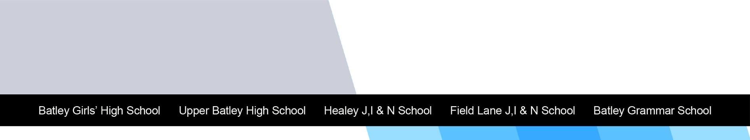

Human Resources
JOB SPECIFICATION

Job Title: Cleaner | Grade: 2
Department: Site Team | Accountable to: Senior Caretaker
Contractual Terms: | Responsible for: N/A

Overall Purpose of the Job:

- Under the direction/instruction of the Senior Caretaker, provide a clean and hygienic school environment which meets specified cleaning standards.
- Ensure that health and safety at the school is paramount at all times.

Key duties and responsibilities
- Your area will be cleaned each day to the agreed standard.
- You will sign in and out of the building, observe COSHH guidelines at all times, report any accidents or incidents and follow health & safety and fire instructions.
- By working as part of a team and being helpful and supportive to stakeholders, you will contribute to a high standard of service and a positive workplace.
- Be aware of and comply with the policies and procedures relating to child protection, health & safety, security, confidentiality, reporting all concerns to an appropriate person.
- Present a positive personal image, contributing to a welcoming atmosphere, treating all users of the building with courtesy and consideration.

Cleaning
- Clean designated areas of the site to agreed standards.
- Sweep, dry mop, wet mop, clean, polish, vacuum floors as required.
- Clean walls, skirtings, internal glazing, remove marks and stains on any such surfaces.
- Dust and polish furniture, fittings, low-level light fittings, ledges and radiators.
- Use electrical machines to clean hard and soft floor areas.
- Collect and dispose of waste in an appropriate manner, empty litter bins, refill and replenish consumables.
- Clean and maintain toilets, wash areas, hand basins, mirrors and floors. This may include occasional removal of bodily fluids.
- Supervision of toilets whilst in use by students.
- Undertake special cleaning programmes during school closure or other designated periods in compliance with the specification for the premises.

Maintaining safety and security of premises
- Update the cleaning record logs.
- Ensure the security of the equipment and materials used during performance of the role.
- Secure entrances/exits and windows as appropriate and reporting potential security breaches.
- Comply with the Health and Safety requirements and guidance of the School.
- Report repair and maintenance work required as required.

Additional Information

To undertake any such duties commensurate with the post as directed by the Co-Heads/Line Manager. The postholder is required to have a good knowledge and understanding of the General Data Protection Regulation (GDPR) and a willingness and commitment to ensure compliance of this regulation and any associated data-related legislation. As part of the wider duties and responsibilities, the post holder is expected to promote and actively support the school’s responsibilities towards safeguarding. This post is subject to an Enhanced Disclosure and Barring Service Check for Regulated Activity.

The duties and responsibilities highlighted in this Job Specification are indicative and may vary over time. Post holders are expected to undertake other duties and responsibilities relevant to the nature, level and scope of the post and the grade has been established on this basis.

As an essential: A good knowledge and understanding of the General Data Protection Regulation (GDPR) and a willingness and commitment to ensure compliance of this regulation and any associated data-related legislation.
All staff: Develop and maintain an awareness of mental health issues affecting both colleagues and students/learners and in act in a supportive way that helps others and enables them to be open about any issues affecting them.

Criteria |  | Essential/ Desirable | How Assessed
Experience: | Experience of cleaning in a school setting or similar environment. | D | A/I
Knowledge and Statutory Requirements: | Knowledge of the operation of tools and equipment.  Knowledge of Health & Safety obligations and understanding of COSHH. | E  E | A/I  A/I
Planning, Organisation and Mental Challenge: | The post holder requires judgemental skills in order to identify straightforward solutions to simple problems. | E | A/I
Interpersonal & Communication: | Ability to exchange straightforward information with work colleagues, students and others. | E | A/I
Physical Skills and Demands: | Willingness to use relevant equipment. Required to do physical duties, cleaning, hoovering, buffing floors, cleaning carpets, dusting at high levels.  Physical demands operating cleaning equipment. | E  E | A/I  A/I
Initiative & Independence: | Able to work on own initiative and as part of the cleaning team. | E | A/I
Commitment: | Commitment to high standards, best value and continuous improvement. | E | I
Personal Qualities: | Able to work with young people and adults.  Flexible to cover staff absences. | E  E | I  I

Characteristics of the post:
The employment checks required of this post are:

- Evidence of entitlement to work in the UK
- Evidence of essential qualifications
- Two satisfactory references
- Evidence of a satisfactory safeguarding check e.g. an Enhanced Disclosure and Barring Service Check for Regulated Activity
- Confirmation of medical fitness for employment as required
- Registration with appropriate bodies (where applicable)

Date Completed: Sep 2021

Signature of Post holder: …………………………………………………………………………………… Date:

This is a description of the job as it exists at present; All Trust Job Specifications are reviewed and are liable to variation in consultation with the post-holder in order to reflect future developments, roles and organisational change.

Please make sure that you can demonstrate your ability to meet the requirements of the job by giving clear, concise examples of how you meet each criterion on our application form.

We recognise and welcome our responsibility to remove any barriers in our Recruitment and Selection process for disabled candidates. We have tried to do this, but if you have a disability and identify any barriers in the job specification, please tell us of these in your application. We are committed to making reasonable adjustments to the job wherever possible and it would help us to know your needs in order to do this.

Where criteria are to be identified through the “Selection Process”, this may involve written exercises, group discussions, presentations, interview, etc.

