Applicant Welcome Pack
Educational Teaching Assistant

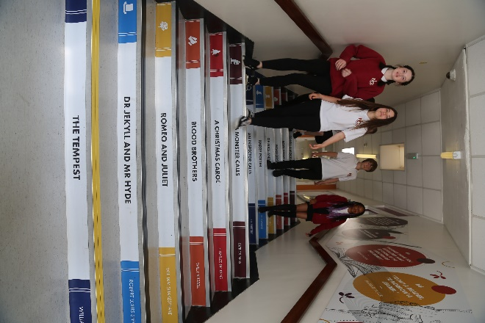
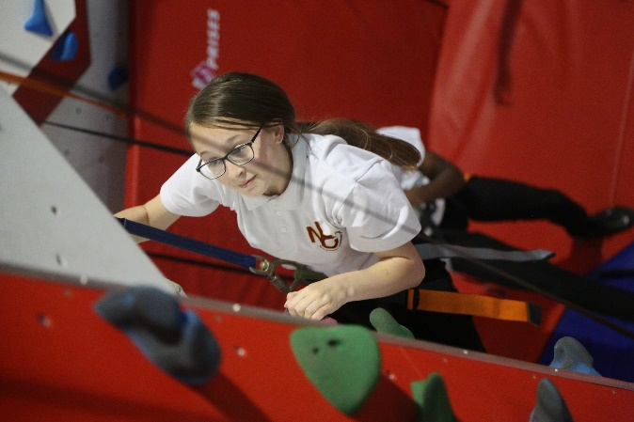

“Success For All”

Letter from the Principal

Dear Applicant,

Welcome and many thanks for your interest in the vacancy at our school. This information pack will provide you with an outline of the role for which you are considering applying and I would encourage you to undertake further research into our school and its community to make sure this is a role in which you can make a significant, positive impact on the lives of our students. Additionally, it needs to be the right place for you to develop professionally and to be happy in the next stage of your career.

Netherhall Learning Campus consists of four schools, covering the full age and ability range from 3 – 19 years, each with its own distinctive ethos; each with its own individual identity and each catering to the specific needs of its students. Whilst the four schools are linked by a common philosophy and by common expectations, each school has its distinct and own characteristics that offer all students a continuous journey from Early Years entry through Key Stages 1 to 4 and beyond to Key Stage 5 via the Studio School. We are made up of a diverse community, yet we are all Netherhall.

Our ethos of ‘Success for All’, caring for each other and achieving excellence, underpin everything that happens in our school. I believe education should have a positive impact on all students and that Netherhall is the right place for this to happen. We have the highest expectations of all our students in every area of school life. Our school is a caring, nurturing and ordered community with an atmosphere of calm and purposeful learning. Students are treated as individuals and we recognise and celebrate different abilities, aptitudes and interests and believe that everyone can develop through dedication and hard work. We aim to create an enjoyment for learning and a resilience that is essential for achieving excellence. We work hard to ensure every young person is happy, safe and successful – a credit to themselves, their family and Netherhall. We aim high.

A culture of excellent teaching and learning is at the heart of everything at Netherhall Learning Campus and it isn’t just for students; we invest heavily in the continuing professional development of all our staff to improve the student experience. Success is not down to one thing but needs some key ingredients: strong classroom practice, an appropriate and personalised curriculum, rigorous tracking and monitoring of progress, commitment and positive behaviour for learning from students and support from home. These coupled with a love for learning and a passionate belief that all can achieve are crucial so that every student can be the best that they can be.

We look forward to welcoming you into our school community.
Michael Kent
Principal
Our Vision
The vision of the Campus is one where everybody will aim to achieve the highest standards and where the Campus will maximise everyone’s potential.

“Success For All”
We will:

- provide relevant learning experiences that will enable students to acquire the essential knowledge, understanding and intellectual, physical and creative skills to equip them for later life.
- leave students at the end of their formal and full-time education with an appetite for acquiring further knowledge, skills and awareness throughout their lives.
- create high expectations of work and behaviour so that each student achieves their maximum potential.
- create a caring community whose basis is tolerance, understanding and concern for other people.
- create an inclusive and supportive environment which helps students become informed, confident, independent, involved and responsible citizens.
- encourage attitudes that enable children to be responsible members of both the school and local community and grow into well-adjusted adults and useful members of society
- recognise our responsibility to provide a safe environment in which all students feel included and valued, and in which there is celebration of all personal achievements and acceptance of diversity.
- broaden students’ horizons and increase their awareness of the world.

About the Campus
Among Kirklees schools, only Netherhall Learning Campus offers children and young adults with a continuous journey from Early Years entry through Key Stages 1 to 4 and beyond to Diploma, AS and A level studies, via the Studio School.

A continuous journey

Pupils may join any of the schools at any time. Regardless of the stage at which they start to attend, all students will experience the unique benefit of an education that has been planned by specialist teachers for all stages of a child’s learning journey.

A common standard and expectation of dress, behaviour and standards of presentation:
- All students, regardless of age, are expected to observe common rules of courtesy, respect, honesty and reliability.
- Uniform is the same across the campus.
- From the start of their school career, all pupils are expected to arrive on time and with the correct equipment.
- Work is always to be presented to the best of the pupils’ ability and books are to be respected and kept in good condition.

A recognition of the importance of parents and carers as partners in the learning journey of our children. A dedicated community team works across the campus to:
- Work with parents to help support their children.
- Encourage greater parent and carer participation in school.
- Support adults who may have had a career break, back into learning and into the workplaces.

High quality teaching
- Teachers across the campus meet regularly to share ideas and good practice.
- They share their expertise and help identify and meet the needs of pupils with special aptitude in their subject area.

Innovative curriculum development
- The curriculum is jointly planned by specialist teachers across the campus to prevent unnecessary repetition and stalling of progress at change of school.
- Creativity and opportunities for artistic and musical development are actively promoted and encouraged.

Information
Thank you for taking the time to read this pack where you will find information about the post and the school.
If you would like to be considered for the post, please complete the application form in full, alongside a letter of application, no more than two sides, outlining your relevant experience to date and the contribution you feel you could make to our school.
Please be assured that we take the time to read and consider all applications we receive. However, it is not possible to give feedback to candidates who have not been shortlisted.
We are committed to safeguarding and promoting the welfare of children and young people we expect all our staff to share our commitment. Further information regarding our safeguarding approaches can be found on our website. The successful applicant to this post will be subject to an enhanced DBS check and other pre-employment checks before the appointment is confirmed. Please note CVs will not be accepted.

Position: Educational Teaching Assistant
Closing Date: Monday 3rd October 2022 at 12pm
Interviews: w/c Monday 10th October 2022
Completed application forms should be returned to: admin@nlconline.org.uk
For a tour of the school, please contact admin@nlconline.org.uk

Joining Netherhall Learning Campus

- Netherhall Learning Campus High School is committed to developing all staff within their roles and creating opportunities for further career progression
- Pension – Every employee has access to the Teachers’ Pension Scheme or West Yorkshire Pension Fund.
- Emotional Wellbeing Support via Employee Healthcare Service including Care First a free confidential counselling service.
- Wellbeing Benefits include annual flu vaccination, staff gym and exercise classes
- Cycle to work scheme

Job Description
JOB TITLE: EDUCATIONAL TEACHING ASSISTANT

GRADE: 6

PURPOSE OF JOB

To work under the guidance of Teaching/Senior Staff to implement and oversee agreed work programmes with individuals/groups, in or out of classroom. This could include those requiring detailed and specialist knowledge in particular areas and will involve assisting the Teacher in the whole planning cycle and the management/preparation of resources.

KEY AREAS

- Teaching Support.
- Pupil Support.
- Curriculum Activities.
- General.

DUTIES AND RESPONSIBILITIES

1. Teaching Support

1.1 To undertake duties in accordance with school practices and procedures, ensuring the job holder actively upholds and promotes the philosophies of the school.

1.2 To work under the guidance of the Class Teacher/Line Manager to plan and monitor pupils learning. Ensuring the progress is clearly recorded in the relevant systems and relates to the learning objectives/goals for pupils.

1.3 As appropriate to assist with the induction and mentoring of new staff within the remit of the role.

1.4 Under the guidance of the Teacher provide one to one support to pupils or working with groups of pupils on pre-planned activities, to reinforce the Teacher’s approach.

1.5 To assist where required in the planning of learning activities.

  - Under the guidance of the Teacher, ensure equipment or materials are suitable for the learning activities. Prepare materials and teaching aids where necessary.

  - Under the guidance of the Teacher, work with individuals or groups of pupils in accessing school library and in the use of ICT and other relevant resources to support learning.

  - To participate in and assist in supervision of educational visits, in conjunction with the Teacher/Line Manager.

1.9 Promote good behaviour, dealing promptly with conflict and incidents in line with established policy and encourage pupils to take responsibility for their own behaviour.

2. Pupil Support

  - Provide support and guidance on a one to one basis or to teams of
pupils in their core skills and curriculum needs as per school policies/practices.

  - To actively encourage the inclusion of all pupils to participate in the life and activities of the school and access the national curriculum to the best of their ability.

  - To provide individual assistance or assistance within groups through implementing behaviour plans, Individual Education Plans and teaching strategies etc, to maximise their achievements.

  - As required to deal with pupils who require physical restraint and intervention, using such methods as TEAM-TEACH, under the direction of the Headteacher.

2.5 As required, to deal with the personal care and comfort and necessary minor medical treatments of pupils, i.e. toileting and intimate care issues (as per school guidance and direction).

2.6 To contribute to plans, reviews and evaluations of pupils by writing reports on pupils’ progress and attendance at meetings.

  - To provide lunchtime cover as required.

  - As required by the school to assist under the direction of the School Nurse and/or Physiotherapist in medically related issues eg. Administer medication-dosage already drawn up by the Nurse, gastrostomy feeding and preparing to care for children requiring other medication administered and Physiotherapy treatment.
3. Curriculum Activities

  - To maintain stock of resources, ordering new replacements as agreed with colleagues, to support the work across the team in its delivery of service.

  - To contribute in the presentation of pupils’ work and maintenance of display areas.

  - To assist with the preparation and tidying of the classroom and upkeep of resources.

  - To attend and contribute to duty related meetings as required.

3.5 To assist in the planning and implementation of structured and agreed learning activities/teaching programmes.

4. General

4.1 As part of your wider duties and responsibilities you are required to promote and actively support the School’s/LA’s responsibilities towards safeguarding. Safeguarding is about keeping people safe and protecting people from harm, neglect, abuse and injury. It is about creating safe places, being vigilant and doing something about any concerns you might have. It isn’t just about the very old and the very young, it is about everyone who may be vulnerable.

Please click here to read our safeguarding policy. Alternatively go to: http://www.kirklees.gov.uk/beta/working-for-kirklees/about-kirklees.aspx

Carry out your duties with due regard to current and future School’s/LA’s policies, procedures and relevant legislation. These will be drawn to your attention in your appointment letter, your statement of particulars, induction, ongoing performance development and through School communications.

Person Specification
 | ATTRIBUTES |  | RELEVANT CRITERIA | HOW IDENTIFIED | RANK
1. | RELEVANT EXPERIENCE | 1.1  1.2 | Experience of working with children/young people in a school environment.  Experience of assisting Class  Teacher in delivering the  curriculum. | Application Form/ Selection Process  Application Form/ Selection Process | A  B
2. | EDUCATION AND TRAINING ATTAINMENTS | 2.1  2.2  2.3  2.4 | Numeracy and Literacy skills to  a level to assist pupils with their  work.  Level 2 Adult Numeracy and  Level 2 Adult Literacy.  NVQ 3 for Teaching Assistants or equivalent qualifications (eg. Level 3 Diploma in Supporting Teaching and Learning in Schools) or experience.  Training in the relevant learning strategies e.g. Literacy. | Application Form/ Selection Process  Application Form/Certificates  Application Form/ Certificates  Application Form/ Selection Process | A  B  B  B
3. | GENERAL AND SPECIAL KNOWLEDGE | 3.1  3.2  3.3  3.4 | Understanding of National Foundation Stage curriculum and other basic learning programmes/strategies.  Understanding of Child Development and Learning.  Understanding and commitment to the Local Authority’s Equality and Diversity Policy and how this relates to the duties of the job.  Knowledge of the national curriculum applicable to the school. | Selection Process  Selection Process  Selection Process  Application Form/ Selection Process | B  B  B  A
 | ATTRIBUTES |  | RELEVANT CRITERIA | HOW IDENTIFIED | RANK
4. | SKILLS AND ABILITIES | 4.1  4.2  4.3  4.4  4.5  4.6 | Effective use of ICT to support learning.  Ability to assist the Teacher in planning class activities.  Ability to communicate effectively with pupils and staff members.  Ability to relate to children/young people from diverse/social backgrounds.  Ability to work as a team member.  Ability to work with children exhibiting behavioural difficulties. | Application Form/ Selection Process  Selection Process  Application Form/ Selection Process  Selection Process  Application Form/ Selection Process  Application Form/ Selection Process | A  B  A  A  A  A
5. | ANY ADDITIONAL FACTORS | 5.1  5.2  5.3 | Understanding of relevant policies/codes of practice and awareness of relevant legislation.  Commitment to ongoing personal training and development.  Willingness to undertake an enhanced Disclosure and Barring Service check. Please note a conviction may not exclude candidates from employment but will be considered as part of the selection process. | Selection Process  Selection Process  Application Form/ Selection Process | B  B  A

Please make sure that you demonstrate your ability to meet the requirements of the job by giving clear, concise examples of how you meet each criteria on your application form. The letters A, B and C in the "Rank" column refer to the importance we will give your answers when we read your applications. You must have all the A's on day one to be able to do the job, you need to have all the B's to do the job, but they could be learnt during the induction, and if you have C criteria this would be an additional bonus. We recognise and welcome our responsibility to remove any barriers in our Recruitment and Selection process for disabled people. We have tried to do this, but if you have a disability and identify any barriers in the job description or employee specification, please tell us of these in your application. We are committed to making reasonable adjustments to the job wherever possible and it would help us to know your needs in order to do this.
Where criteria are to be identified through the "Selection Process", this may involve written exercises, group discussions, presentations, interview etc.

