Educational Teaching Assistant post x 2

Information for Candidate

Birmingham Lane

Meltham

Holmfirth

HD9 5LH

Tel: 01484 859032

With Compliments

Liz Woodfield
Headteacher

MELTHAM MOOR PRIMARY SCHOOL

Birmingham Lane, Meltham, Holmfirth. HD9 5LH

Head Teacher – Liz Woodfield
Tel: 01484 859032
e-mail: office@melthammoor.org
website: www.melthammoor.org

January 2023

Dear Applicant,
Thank you for your interest in the post on offer at our school. We hope this information pack containing details of the position and the school is helpful.
To assist you in making a successful application, the points below are given for your guidance:
- A supporting letter should address all criteria in the Personnel Specification.
- This letter should be no more than two sides of A4 using Arial font no less than size 11
- Completed forms should be handed in at the school or emailed to office@melthammoor.org by 4.00pm on Wednesday 8th February 2023
- Shortlisted candidates will be notified on Thursday 9th February 2023
- Observations and interviews will be held on Wednesday 22nd February 2023
- A CV is not required.

Yours sincerely,

Liz Woodfield
Headteacher

When schools collaborate, incredible things happen.
Together Learning Trust is a thriving group of six schools, three secondary and three primary, inspiring over 3500 young people. We are driven by a shared commitment to providing magical learning experiences for all our children and a belief that all of them can achieve great things.

Exceptional achievement stems from developing world class teaching and learning. Creativity is the core of our values. Our staff are amazing, in both the relationships they forge and the incredible range of opportunities they make possible. We get great results, but we give and expect so much more. We are shaping a generation of future global citizens with the character they need to succeed; with the integrity and commitment to excellence that will enable them to thrive.
Together Learning Trust schools are wonderful places to work. We value and support our team across all our schools, and recognise the ideas, experience and expertise of our staff. Being part of the Trust opens up new opportunities for staff development. The Trust schools work closely together to identify and then implement the best school improvement strategies across its schools. Our aim is to grow great people and talent.

We cherish our staff, support their wellbeing and enable them to flourish. We never stop learning, so we invest in both our teachers’ and schools’ development and by reaching out to leading educational research to keep ahead of our game. Being part of Together Learning Trust feels special due to the unique nature of the schools and the opportunities it brings for staff, students and communities to collaborate. For everyone involved in our Trust our mission is simple. To Grow, Excel, and Learn Together.
What could we do, together?

David Lord, CEO of the Together Learning Trust

www.togetherlearningtrust.co.uk

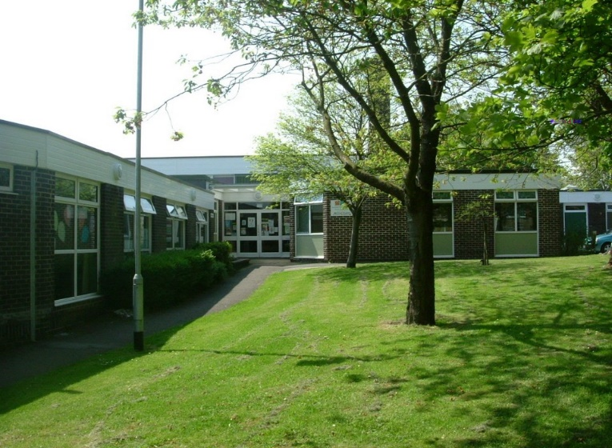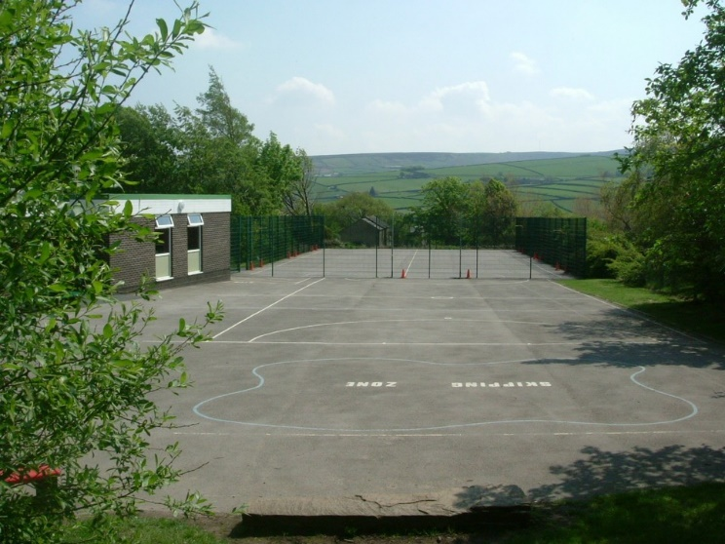

Meltham Moor is a through primary school set in beautiful surroundings on the edge of the Peak District National Park. We have approximately 220 children in classes ranging from Nursery to Y6.
Our school vision statement is clear:
‘At Meltham Moor we will endeavour to ensure that every child can achieve their best personally, socially and academically’.
Our values are:
Aspiration - encouraging everyone to be the best that they can be.
Confidence - being prepared to take risks, without fear of failure, and developing self-esteem from recognising achievements.
Resilience - being able to bounce back and try again.
Compassion - being friendly, caring, well-mannered and behaving appropriately, supporting and respecting each other.
A love of learning.

Trustees, Governors and staff believe that children work better and learn more effectively in an atmosphere of friendliness but within a framework of good order which engenders good behaviour. Emphasis is placed upon the establishment of good relationships between staff and children and between home and school.

In September 2019, Meltham Moor entered the newly formed Together Learning Trust. Being part of the Together Learning Trust will enable our schools to continue to flourish and develop within a supportive school focused community, where the expertise of those who have a hands on understanding of our children will lead the way forward.

At Meltham Moor we aim for children to develop awareness of responsibilities towards themselves, others and their environment. The children are actively encouraged to make positive contributions to their own education, school and community in general. We are a happy, positive school and we look forward to a productive time and successful future. We believe strongly in the partnership between home and school and want families to be actively involved in supporting children's learning and the school.

Applications are invited for the post of:

Educational Teaching Assistant x 2 posts
Grade 6 (SCP 7-11)
(26.25 hrs, 9.00am – 3.15pm with 1 hour for lunch)

Fixed Term dependant on specific funding, to 21.7.23

These posts are on a fixed term basis subject to the needs of the pupils and budgets, they may not go beyond 21st July 2023

We are looking for a friendly, flexible and caring person to join our school, supporting individual children. The hours are 26.25 (9.00am – 3.15pm with 1 hour for lunch).

Experience of working with children in a school environment and knowledge of the national curriculum is essential. Experience of working with children with additional needs and an understanding of positive behavioural support approaches are also essential. Applications are invited from individuals who are enthusiastic, positive with good communication skills and able to work as part of a team to support children’s learning.

We are committed to safeguarding and promoting the welfare of children and young people and expect all staff and volunteers to share this commitment. All staff are subject to an enhanced DBS check. A conviction may not exclude candidates from appointment but will be considered as part of the recruitment process.

If you require further information about the role, please contact the school on telephone 01484 859032 or you can visit the school website at www.melthammoor.org

Teaching Assistant
Job Description

Job Title | Teaching Assistant
Location | Meltham Moor Primary School
Contract Terms | Fixed Term, 26.25 hours per week (Term Time Only)
Salary/Grade | Grade 6 £13,337 – £14,341
Key Responsibilities | - To set up enhancements under the direction of the class teacher to help to create a stimulating environment in order to enhance the children’s social, emotional and educational development.  - To ensure that a caring and stimulating environment is provided for children that takes into account individual developmental needs and enables children to reach their full potential.  - To support pupils who need help overcoming barriers to learning because of social, emotional and behaviour difficulties  - To share in the responsibility for safeguarding and promoting the welfare of children.  - Establish good relationships with children; interact positively with children, encouraging cooperation and mutual support; monitor pupil’s well-being and readiness for learning.  - Adhere to the school’s policies and procedures to ensure that high standards are maintained within the classroom.  - Establish relationships with parents/carers of children to ensure they are engaged in the child’s education and development.  - Support the work of the class teacher to ensure that children have access to a suitable curriculum that enables children to achieve  - Take responsibility for recording information which can be shared with parents/carers and other professionals and agencies (subject to confidentiality).  - Be aware of policies and procedures relating to child protection, health, safety, security and confidentiality reporting all concerns to the line manager to ensure children’s wellbeing.  - To undertake focused learning opportunities with all children demonstrating high expectations and standards.  - Promote the safety and wellbeing of pupils, and help to safeguard pupils’ well-being by following the requirements of Keeping Children Safe in Education and our school’s child protection policy  - Working with others in providing day-to-day guidance and support for pupils who disrupt the learning of other  - To actively encourage the inclusion of all pupils to participate in the life and activities of the school and access the national curriculum to the best of their ability  - As required to deal with pupils who require physical restraint and intervention, using such methos as TEAM-TEACH, under the direction of the Headteacher
Other roles and responsibilities | - To work as part of the staff team and contribute to plans to ensure the aims are met.  - To take part in any CPD activities appropriate to the role.  - Support the implementation of initiatives and policies e.g., data protection, child protection, health and safety.  - The postholder will be required to undertake any other professional duties as required by the line manager.  - To have a clear understanding of child development and use this knowledge when interacting with the children in the indoor and outdoor environments.  - Uphold public trust in the education profession and maintain high standards of ethics and behaviour, within and outside school  - Have proper and professional regard for the ethos, policies and practices of the school, and maintain high standards of attendance and punctuality
Other specific duties | Whilst every effort has been made to explain the main duties and responsibilities of the post, each individual task may not be identified. Employees will be expected to comply with any reasonable request from the Chief Executive Officer/ Headteacher to undertake work of a similar level that is not specified in this job description.  This job description is current at the date shown. It will be reviewed at least annually and, in consultation with you, it may be changed by the Chief Executive Officer / Headteacher to reflect or anticipate changes in the job commensurate with the grade and job title.

Teaching Assistant
Person Specification

Criteria | Essential | Desirable
Qualifications/Training
NVQ level 3 (or equivalent) relevant to working within Education | ✓
Good standard of general education (i.e. NVQ level 3 or equivalent) together with good numeracy, literacy and ICT skills. | ✓
Commitment to own professional development. | ✓
Recent safeguarding training. |  | ✓
Recent Team-Teach training |  | ✓
Participation in a range of school-based training/CPD. |  | ✓
Experience
Experience of planning and leading teaching and learning activities (under supervision) | ✓
Successful experience of leading and supporting the learning of children including those with additional Special Educational Needs. | ✓
Successful behaviour management experience. | ✓
Have cared for and nurtured young children in a school environment | ✓
Experience of supporting teachers in providing high standards of teaching, learning and play for pupils | ✓
Experience of supporting students with specific learning difficulties | ✓
Experience working with young children | ✓
Ability to produce accurate written records on child development | ✓
Experience of working within a team | ✓
Experience of delivering support to young children | ✓
Understands how young children learn and make progress | ✓
Knowledge and skills
Understanding of effective teaching methods | ✓
A commitment to providing a range of appropriate learning activities indoors and outside. | ✓
Ability to use ICT effectively to support and enhance learning. | ✓
Ability to self-evaluate learning needs and actively seek learning opportunities. | ✓
Knowledge of how to successfully lead learning activities for class of children | ✓
Knowledge of how statutory and non-statutory frameworks for the school curriculum relate to the age and ability ranges of the learners they support | ✓
Knowledge of how to support learners in accessing the curriculum in accordance with the SEND code of practice | ✓
Effective communication and interpersonal skills with both adults and children | ✓
Ability to work with and motivate young children | ✓
Ability to communicate effectively both verbally and in writing | ✓
Ability to see a situation through to conclusion | ✓
Ability to remain calm under pressure | ✓
Good ICT skills to aid students learning | ✓
A good standard of literacy and numeracy | ✓
Good organization skills | ✓
Good motivation skills | ✓
Be able to establish a rapport with the children and their parents/guardians/carers. | ✓
Demonstrate an understanding of the needs of young children | ✓
Personal Qualities and Attributes
Initiative, flexibility and ability to work independently | ✓
Commitment to equal opportunities | ✓
Commitment to Safeguarding | ✓
Caring and positive | ✓
Reflect on and develop professional practice | ✓
Interacting professionally with colleagues and parents | ✓
Excellent rapport building with young children | ✓
Ability to work as part of a team | ✓
Open minded and flexible | ✓
Ability to follow instructions or work on own initiative as necessary | ✓

Safer Recruitment

Meltham Moor is committed to safeguarding and promoting the welfare of children and young people and expects all staff and volunteers to share this commitment.

Safer recruitment practice aims to minimise the risk of appointing individuals who are unsuitable to work in a post where they will be in contact with children or vulnerable adults and could cause them harm.

Our selection processes observe best practice in selecting the appropriate candidate by ensuring equality of opportunity for all applicants whilst excluding any who may be unsuitable to work with our children.

The Disclosure and Barring Service (DBS) helps employers to make safer recruitment decisions and to prevent unsuitable people from working with vulnerable groups, including children.

It is a criminal offence to offer to a barred individual (or indeed for a barred individual to apply for, or to accept an offer of) employment in certain designated posts (those which involve working with children in what is defined as regulated activity).

All candidates are expected to understand their own responsibilities and duties in regard to child protection and safeguarding with due relevance to the specific post advertised.

